To those who have contracted the following diseases:

-Enterohemorrhagic Escherichia coli infection

-Shigellosis

-Typhoid Fever,

-Paratyphoid Fever

-Cholera

Gunma Prefectural Government

You have acquired diseases that could be highly contagious.

The bacteria that caused your disease is in your stool. Even if you don’t develop any symptoms, some bacteria in your stool cause diseases. The bacteria, if they enter someone’s mouth, even a very small amount, could cause them to contract diseases. If children or elderly people contract diseases, they could get very serious.

The law stipulates that until such time that there are no bacteria in your stool, you cannot work where you touch foodstuff. If you do, it is against the law.

Please take the medication as prescribed and instructed by your doctor.

If you have any questions regarding this matter, please ask your local public health center *(Hokenjo* in Japanese).

Hokenjo:Phone Number:  **＿＿＿＿＿＿＿＿＿＿＿＿＿＿＿＿＿＿＿＿**

Avoid transmitting your diseases to other people.

There are many bacteria in someone’s stool.

Those bacteria may enter other people through your hands.

**Make sure you wash your hands after you go to the toilet, before eating meals, and before preparing food.**

Use soap to wash your hands.

Wash them for at least 30 seconds.

Do not let other people use your towels.

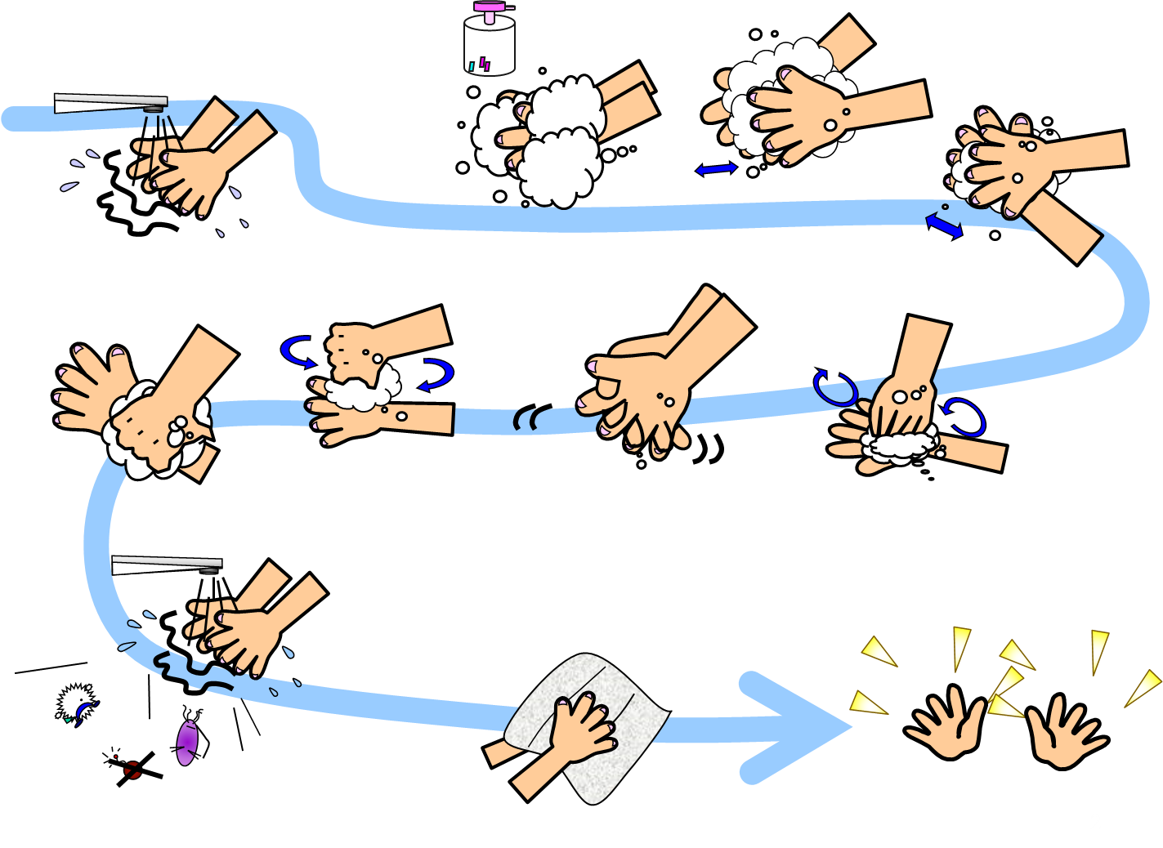

Disinfect the places where you have touched daily.

Spray some disinfectant onto paper towels to wipe off the doorknobs and facets.

After taking a bath, use soap to clean the bathtub and the area you used.

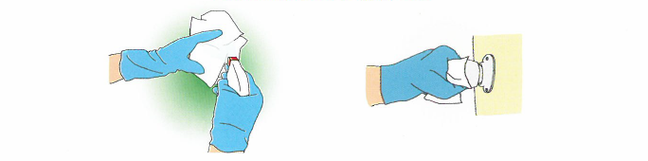

Disinfect the dirty clothes with stools.

Dirty clothes with stools may have bacteria.

Rinse away the stools from the clothes and then disinfect them. Wash them separately from other clothes.   
To disinfect dirty clothes, let them soak into sodium hypochlorite for 30 minutes or

simmer them with hot water for ten minutes.   
If you soak clothes into sodium hypochlorite, they may turn white.

Precautions to take care of someone who has contracted a disease.

Wear gloves to clean up the sick person’s stools.   
Wear gloves to change the diapers of a sick baby.

Put dirty diapers into a plastic bag to dispose of according to the rules set by the city/town/village office.

After finishing taking care of them, remove and dispose of the gloves. Wash your hands with soap immediately.