1. Write your name both on the container and the lid.

Your Name

Your Name

1. Sit on a toilet seat as illustrated.

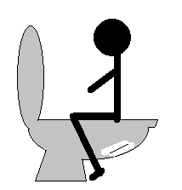

1. Use chopsticks to put the stool, as much as illustrated to the right, into the container.

When you have diarrhea, use a spoon to scoop the stool.

Your Name

Put the used chopsticks and a spoon into a plastic bag and

dispose of them according to the rules set by the city/town/village office.

1. Close the lid.
2. Put the container into a bag.
3. Write down the date when you sampled your stool.
4. Bring it to the public health center (*Hokenjo* in Japanese) by month＿＿date ＿＿.
5. After you have sampled your stool, wash your hands with soap.

Hokenjo: Phone Number:＿＿＿＿＿＿＿＿＿＿＿＿